# Law & Order SVU News: Tamara Tunie Returns As Dr. Melinda Warner

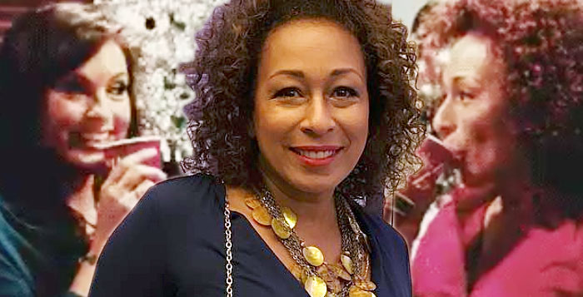

Law & Order: SVU Tamara Tunie

Twenty years ago in November, Tamara Tunie made her Law & Order: SVU debut as Dr. Melinda Warner, M.E. (Medical Examiner). Now, the actress reveals that she’s coming back to the show this coming season!

### Tamara Tunie Returns to Law & Order: SVU

“And Season 22 begins!” [Tunie](https://soaphub.com/entertainment/law-order-svu-stars-mariska-hargitay-tamara-tunie-discuss-authenticity/) posted on Instagram. “And DR. WARNER is BACK!!! So happy and full of thanks, to be working!!🙏🏾👏🏾👍🏽”

***FEATURED VIDEO:*** [**Your Favorite Soap Stars Want You To Get Out The Vote**](https://soaphub.com/video/?inposttext=1)

Ad

Tunie appeared regularly, many times a season starting in late 2000 until 2015. She popped up again for an episode in 2018 and another the following year. Her most recent episode, titled Murder at a Bad Address, was in October 2019. From her debut, Dr. Warner has delivered key information to the show’s detectives that is necessary for them to solve their cases.

While Melinda is always professional, Tunie plays the character with heart and humanity. This was especially evident in an episode in Season 5 when Melinda privately informed Olivia that her HIV test had come back negative.

Ad

Tunie’s not the only one coming back this season. Fans are anticipating [the return of Chris Meloni](https://soaphub.com/entertainment/chris-meloni-brings-law-order-svus-elliot-stabler-back-to-nbc/) as Det. Elliot Stabler. He’ll star in a new series Law & Order: Organized Crime, set to debut in 2021. Viewers can’t wait to see Elliot and his former partner, Olivia Benson (Mariska Hargitay), now a Captain, interact once again.

Along with posting the news that she’s back, Tunie shared a photo of a sticker related to her work. It reads: “Welcome back, everybody! Obviously, your health is our number one priority, so please obey all of our new COVID-19 rules. Use discretion and social distancing when you are not work – your fellow artists are all relying on you for their health and livelihood.

“Have a safe and successful new season!” The note was signed by Dick Wolf, the series creator and executive producer.

Tunie is known to soap fans for her lengthy run as savvy attorney [Jessica Griffin](https://soaphub.com/entertainment/five-fast-facts-former-law-order-svu-star-tamara-tunie/) on As the World Turns. She began playing the legal eagle in 1987. Law & Order: SVU returns on Thursday, November 12 on NBC.

***SUBSCRIBE NOW:*** [**Get our Entertainment stories and news in your email!**](https://soaphub.com/entertainment-subscribe/?utm_source=SH&utm_medium=web-textad&utm_campaign=text)

